HYPOTHESIS B DISCUSSIONS:

Figure 9 is a box plot to display the relationship between gender (Male or Female) and score (percentage) in the ANS task. Whiskers are used to display the range of the scores for each gender and the orange line is used to display the median score for each gender. The white circles represent anomalies, thus showing two anomalous scores out of the Male scores and two out of the scores obtained by Females.

Upon generating a boxplot between males and females for the ANS task, one can observe that generally, males have scored slightly less within this test. This is mainly shown through the median indicating a central tendency of scores for males to be ~90. The range of scores for males is observed to be lesser than that of females, as denoted by the length of the whiskers of the plot. This observation could indicate that results by the male participants were more consistent and clustered around the median, subsequently displaying a smaller range of results. This point is further amplified by the position of the median being close to the upper interquartile range, which suggests that the data is skewed and concentrated in that region. However, due to the ratio of the sample of participants being 7:14, Female:Male, the lack of male participants may distort the validity of the whiskers for this graph to denote dispersion, as well as subsequent box plots for the male strata. The data for the female participants appears more symmetric in this figure, more accurately fitting a normal distribution. Despite such differences in appearance of singular aspects for each box plot, there is substantial overlap with the score ranges. For the ANS test, several outliers were observed – two male and two female participants. Outliers produced may have been caused simply by individuals rushing through the test or guessing, but specific reasons cannot be determined through this analysis alone.

Figure 10 is a box plot to display the relationship between gender (male or female) and score (percentage) in the Maths test. Whiskers are used to display the range of the scores for each gender and the orange line is used to display the median score for each gender.

Qualitatively, one could presume that the interquartile range to be similar between both strata for the math test, as represented by the length of the box. This shows that the 25th-75th percentile of results was distributed in similar manners. Despite this, the whiskers for the minimum and maximum values for the female participant scores were higher for both the upper and lower ranges of the male participant plot. Therefore, one can conclude from this box plot alone, that for this study, females performed better in the vast majority of trials of the math test. Interestingly, from figure 10, it is observed that the median average for males was higher than that of the median results of the female participants. This could be due to the shorter upper extreme, denoting lesser dispersion of results from the upper quartile. The main contributor to the lack of dispersion, as mentioned afore, could be attributed to the lack of male responses to the tests.

Figure 11 is a box plot to display the relationship between gender (male or female) and score (percentage) in the Memory test. Whiskers are used to display the range of the scores for each gender and the orange line is used to display the median score for each gender.

The boxplot for the relationship between gender and score in the memory test exhibits female participants scoring a median higher than the males. Results for female participants spans 0-100%, with a slighter larger interquartile range, in addition to the longer whiskers for both minimum and maximum values in comparison to those of the male results, indicating that the results were widely dispersed to the extent that no score possible would have been an outlier. The lower whisker is approximately 3 times the length that of the whisker leading up to the upper extreme however, the median value is only slightly displaced from the middle of the interquartile range. This displays that there was not too much clustering of high results to skew the data by a substantial amount. Male participants on the other hand, displayed lower scores generally, accompanied by a slightly shorter interquartile range and a shorter whisker for the lower range. The male participants displayed no upper range for this test, thereby denoting that there were no outstanding high scores, whereby the data would shift, but experienced several scores at 60% maximum as this was the upper quartile and the upper extreme too.

Figure 12 is a box plot to display the relationship between gender (male or female) and score (percentage) in the ANS task. Whiskers are used to display the range of the scores for each gender and the orange line is used to display the median score for each gender. The white circles represent anomalies, thus showing one anomalous score out of the male scores.

The generation of a boxplot for the spatial reasoning task, visually displays the largest disparity in the relationships of gender and the corresponding score within the spatial reasoning task. From this figure, one may be able to deduce that male participants scored relatively higher on average to the female sample. Given that there is no upper range whiskers for the plot for male participants, it can be said that from this task alone, most of the male participants had scores clustering around full marks, and perhaps this male strata were exceptionally good at spatial reasoning. However, this cannot be confidently concluded by qualitative observations alone. Without knowledge of temporal aspects involved, the clustering of results around 100% for male participants doing this spatial reasoning test could actually indicate higher risk aversion, and that female participants were more willing to risk undergoing negative marking potentially as a trade-off of taking lesser time to complete the quiz. Unless these two aspects of time and how many trials each participant took for this quiz, it is impossible to conclude a strong generalisation on the relationship between gender and the score for this quiz, and how it was achieved. As with most of the tests, the spatial reasoning task suffers from a small sample size and this can be partially demonstrated by the wide range of results for the female participants, ranging from 65-100%, whilst the male participants have concentrated results from 90-100%, with an outlier at 80%.

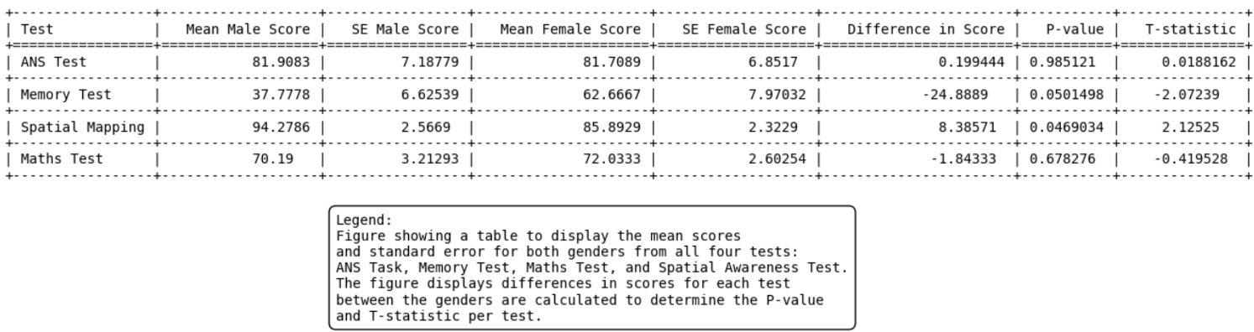

The table explores the significance of the differences between the score obtained by males and females on all four tests. The mean scores obtained by males and females were initially calculated from which the standard error could be obtained as a measure of variability and accuracy of the mean scores in representing all scores. The difference in scores was calculated between the genders for each test, and this was in reference to the male score. Thus, a positive difference indicates males had an average mean score for that test, whereas a negative score indicates females had an average mean score for that test. To assess the significance of the difference the P-value and T-statistic were calculated. The p-value implies the probability of observing the given T-statistic if there was no true difference between the male and female scores for the tests, thus is the P-value was less than 0.05 null hypothesis is rejected and a statistically significant difference between the male and female scores can be seen. The smaller the P value, the larger the T value, however the sign before the T-statistic value shows the direction of the difference- a positive sign means males scored higher on average on that test whereas a negative sign means females scored higher on average on that test. As the calculated P-value is only below 0.05 for the Spatial Mapping test, it can be concluded the null hypothesis can be rejected and there is a significant difference between males and females and their performance on the spatial mapping test. For the ANS test, memory test and maths test, the P-value is below 0.05 so the null hypothesis is accepted and there is no significance between the genders and their performances on these tests.

Through statistical analysis of using unpaired t-tests for each cognitive task performed, a dot plot was generated as shown in figure 13. This plot demonstrates a side-by-side comparison of the distributive data and the confidence intervals, based on the mean average score for each gender and the range.

Generally, between each test, from highest to lowest in average scores performance is spatial mapping, ANS, maths and memory. This trend of having the scores in an ordered manner for both genders does not demonstrate any phenomena or extraneous effect had on the participants in particular. For example, though the spatial reasoning task had the highest performance in terms of percentage score, this observation could potentially be attributed to several aspects. Firstly, the task may not have been perceived as easy, but in the opposite manner, quite difficult, causing for participants to take extra caution in answering. Due to the nature of how the test was conducted, each participant could have used less trials, knowing they had the risk of negative marking, and took each question within the test with much more perceived caution, taking the test slower, thus resulting in a higher precision overall. This contrasts to the nature of the other tests, notably the memory and ANS test, in which participants are only given a short set period of time to click the right answer, essentially imposing an ultimatum on the subject, whereby the participant has to make a conclusive decision, thus resulting in a wider range of results, as demonstrated by the extensions of the error bars in the dot plot.

ANS and spatial mapping had a higher mean value for male participants, whilst for memory and maths had higher mean values for female participants. Assessing the nature of each quiz and what was tested from a neural standpoint, there appears to be no fundamental or distinct differences in the way males and females approach the different cognitive tests. Therefore, it can be concluded that there is no inherent difference in the ways males process, store or decode certain forms of information to females and vice versa.

HYPOTHESIS A DISCUSSION

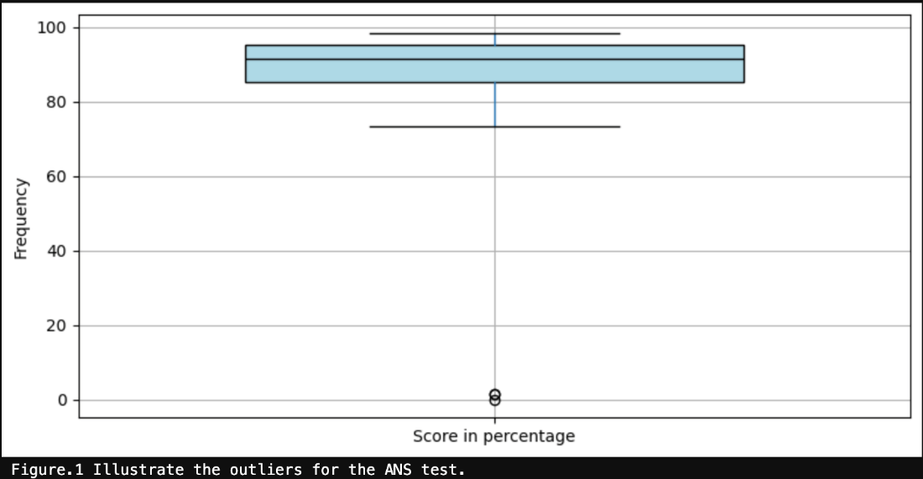

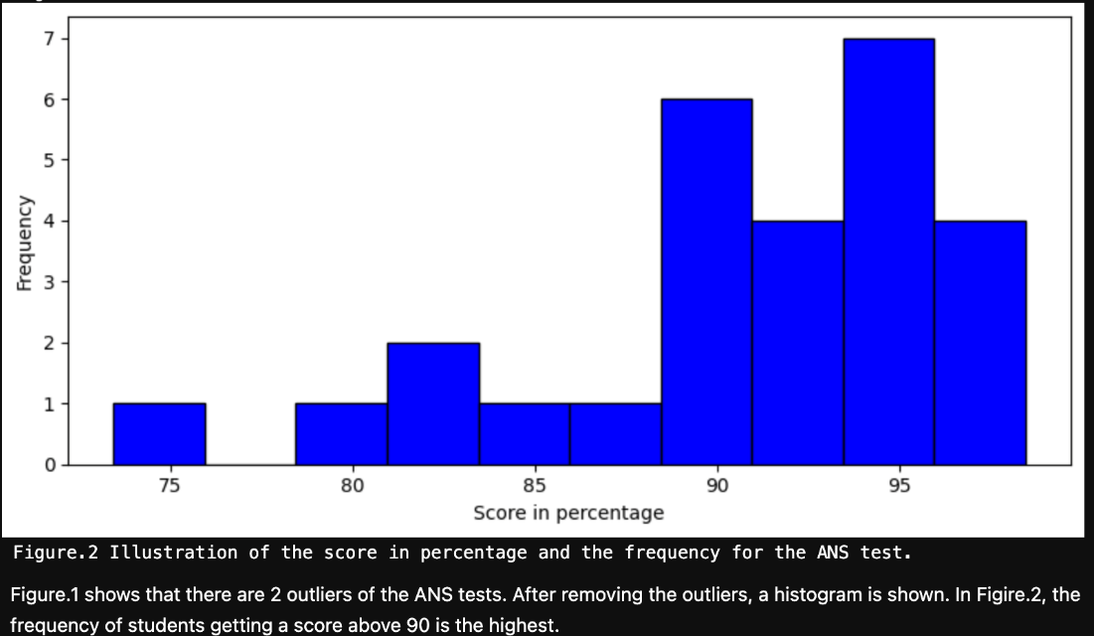

Overall, for all participants taking the ANS test, apart from two anomalous results produced, the scores are close to being distributed normally, but are slightly skewed to the higher end. This is demonstrated by the median value in figure 1 to be slightly above the middle of the interquartile range box. The length of the whiskers for the box plot reflects this point, in addition to the histogram of figure 2, showing that frequency of scores above ~87 increases and are clustered around the 90-100 range.

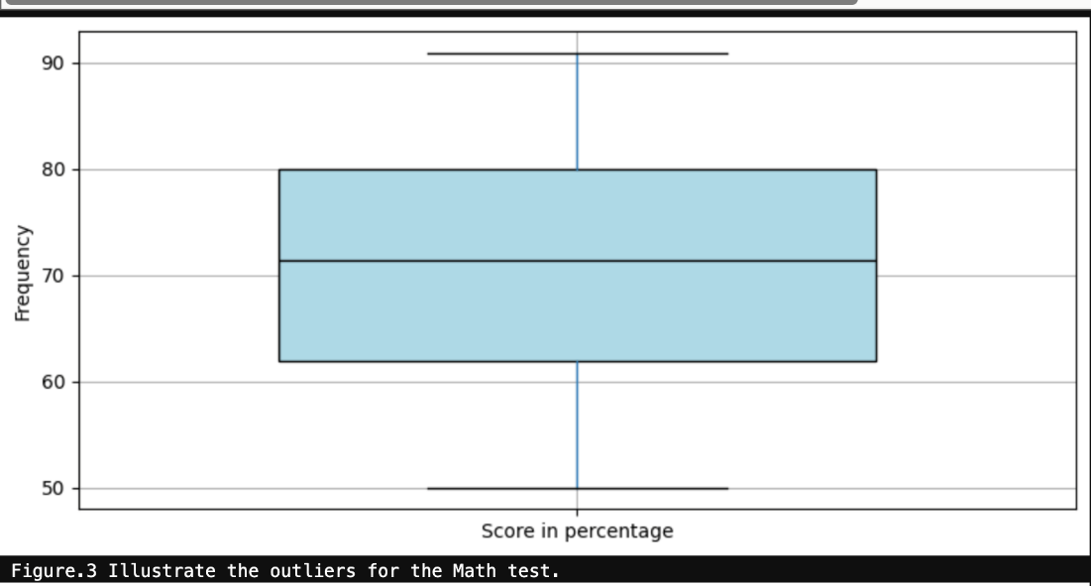

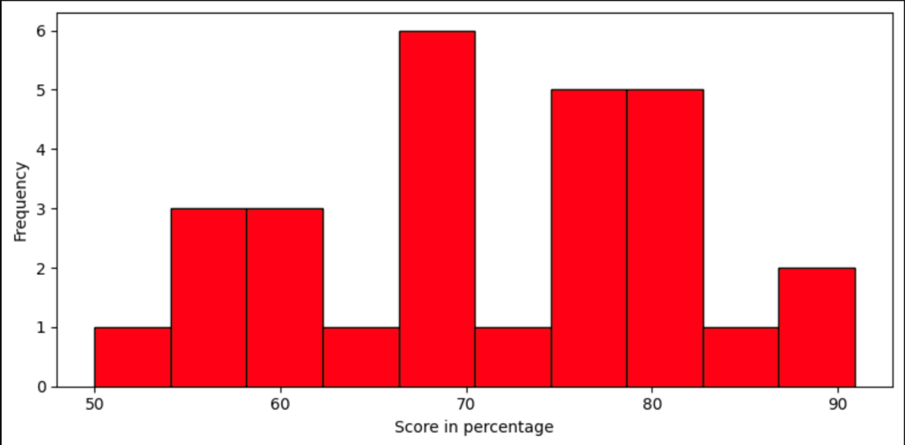

Analysing the whole sample of participants who took the math test, figure 3 demonstrates that the scores have a wide range from 50-91, demonstrated by the long whiskers for the box plot. These whiskers appear to be roughly the same length, and in addition, the position of the median value within the interquartile range being in the middle of the box, gives the implication that the distribution of results are symmetric, and thus normally distributed. This conclusion is amplified by the histogram of figure 4, which could be seen as fitting a bell curve.

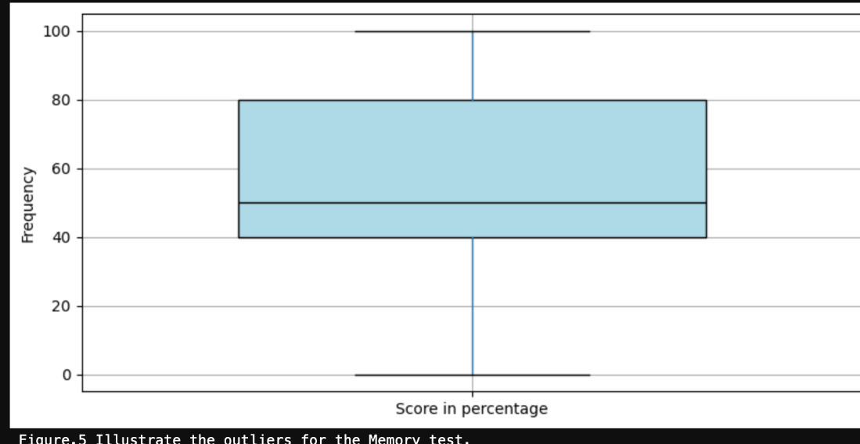

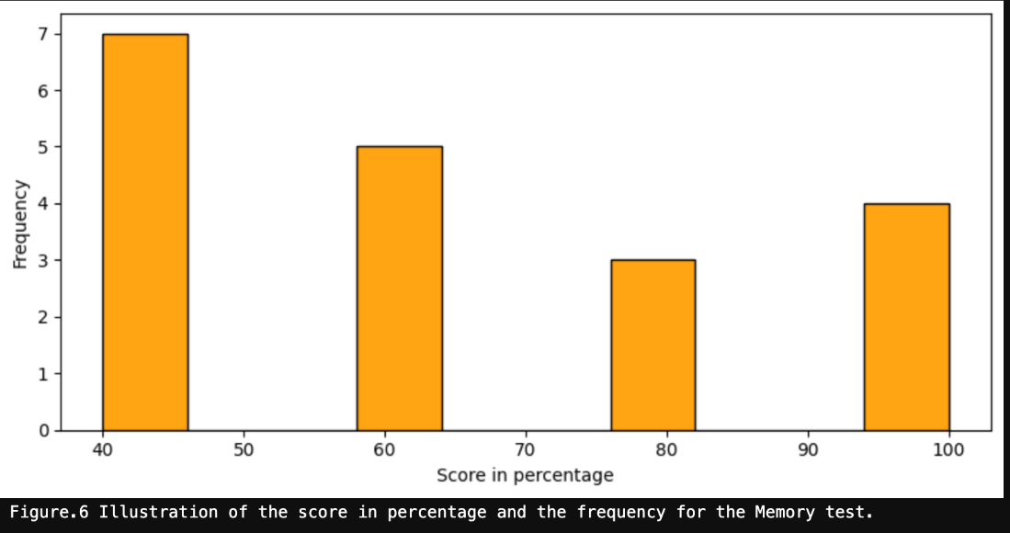

Figure 5 demonstrates that the range of results for all participants taking the memory test spans 0-100%, with no outliers. The interquartile range of results ranges from 40-60, however, as the median value is ~45, this indicates a slight asymmetric distribution of results, skewed slightly to the lower end. This shows that most participants got less than half of the questions right for this test.

Figure 7 demonstrates that the scores have a wide range from 50-91, demonstrated by the long whiskers for the box plot. These whiskers appear to be roughly the same length, and in addition, the position of the median value within the interquartile range being in the middle of the box, gives the implication that the distribution of results is symmetric, and thus normally distributed. This conclusion is amplified by the histogram of figure 8, which could be seen as fitting a bell curve.

The table explores the significance of the correlation between the ANS test and each of the other tests (memory test, maths test, spatial awareness test) using spearman’s rank statistical analysis. Within a spearman’s rank test, a measured correlation value close to -1 indicates a negative correlation, a correlation value close to +1 indicates a positive correlation and a measured correlation value close to 0 indicates no correlation. As the measured correlation values for all three tests compared to the ANS test are all closer to 0 than to either +1/-1 no correlation can be identified. As the P-value for all three conditions are larger than their respective measured correlation values, the null hypothesis can be rejected as there is no identified significance for the correlation between the ANS test and any of the 3 tests.